Corneille Rayim-Wend OUEDRAOGO 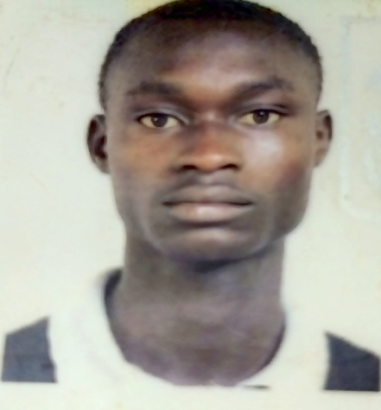

Email [ocorneille@gmail.com](mailto:ocorneille@gmail.com)

Phone 56 09 54 25

Address Koudougou, Burkina Faso

Birth date 10/06/2001

**EDUCATION**

10/2023 Burkina Institut of Technology, Koudougou, Burkina Faso

10/2020 06/2024 College Evangelique the Charity of Koudougou,Burkina Faso

• Scientific Baccalaureat (D)

• Specialization Natural Sciences and French

**ADDITIONAL INFORMATION**

Extra curricular • BIT English Club (member)

activities • Member of the Koudougou regional choir , Burkina Faso( CRK BF)

Languages • English (Average)

• French (Average)

• Moore (Native)

Personal interest • English Music

• Recherch about mining programing and cyber- security

• Practice the sport (Football)

• Love to sing (Choir)

• Practice gardening

Koudougou, 02/02/2025

Corneille OUEDRAOGO

